Celestial Navigation
Senior 1: Cluster 4: Exploring the Universe
S1-4-03: Investigate how various cultures used knowledge of the position and motion of visible celestial objects for navigation.

Introduction:
The purpose of this lesson is to investigate how ancient cultures used the North Star to navigate. By the end of these activities students will, 1. Understand how cultures in the past used the position and motion of the North Star for navigation 2. Understand why navigation was important. 3. Know how to find the North Star and other constellations including the Big Dipper. 4. Explain how Stars move across the night sky. 5.Explain how to find latitude using a sextant and the North Star.

Ancient Navigation
Note: Early navigators used recognizable landmarks to navigate by hugging the coast and staying in known waters. If they ventured into the open ocean or to unknown waters, there were no recognizable landmarks. The Vikings were the first to venture on long journeys into the open sea. The Polynesians and Europeans also used the stars, sun and the moon to help them navigate.

Check your current understanding:
(1) How do modern sailors find their location? (GPS or satellite)

(2) What did sailors need to know to avoid getting lost? (where they were and where they are going/latitude, longitude and compass direction)

(3) What were some dangers that sailors faced in the past? (storms, getting lost, starvation, thirst and disease)

(4) Why did some sailors hug the coastline? (To avoid getting lost)

(5) Why was hugging the coastline not a good strategy? (limited the places they could go. Not reliable)

(6) Why was the North Star important for navigation? (An important way to determine north)

(7) What was the disadvantage of using the North Star to determine direction? (Hidden during cloudy nights.)

(8) How does the North Star move during the night? (stays fixed)

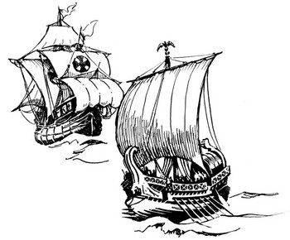

Teacher Demonstration
Part A: Star Trails
Begin by showing students a star trails photograph of how stars move across the night sky in the northern hemisphere. Try to draw out more in-depth reasoning for the circular pattern and the star in the middle, explaining that the picture is of star trails due to the earth's rotation. Guide the students towards the idea that Polaris, the North Star, does not move because it is directly above the Earth's axis of rotation making it an ideal reference point for navigation. The stars and the sun, were fixed in the sky and could be seen anywhere, therefore they became reliable for navigation.

Terms to know:
- Navigation
- Latitude
- Longitude
- North Star (Polaris)
- Little Dipper (Ursa Minor)
- Northern Hemisphere
- Equator
- Southern Hemisphere
- Constellations
- Circumpolar Constellations

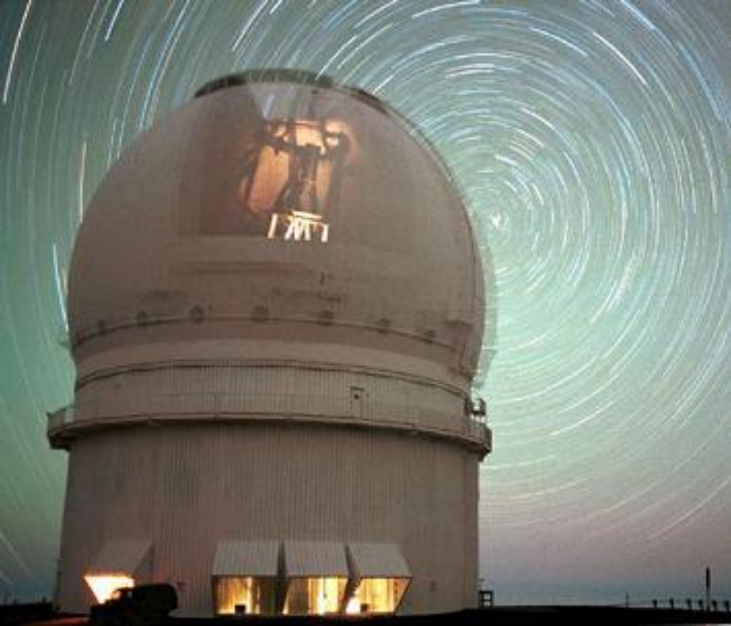

Star Trails Brainstorm Questions:
1. What is the picture of? (Stars/star trails)
2. Why does the photograph look this way? (The stars move in a circular pattern)
3. What is the bright star in the middle? (Polaris)
4. Which star remains fixed? (Polaris)
5. Why is Polaris not directly overhead when we look at the night sky? (Because we are not at the North Pole.)
6. How high is Polaris in the sky? (It depends on where you are.)
7. How many degrees does the earth rotate in one day? (360º)
8. Draw A) the Earth and label the northern and southern hemisphere, the equator and the North Star. B) A star trails diagram.
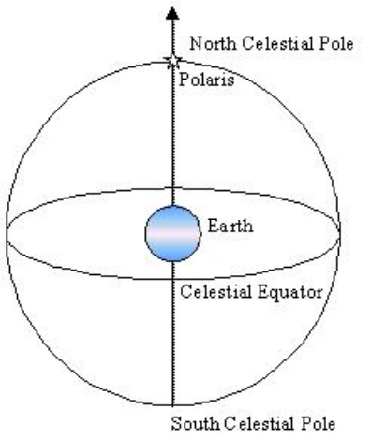
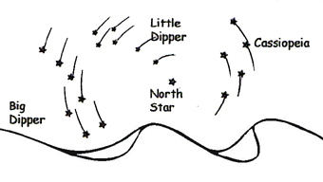

Part B: Finding the North Star
Explain to students if they want to use the North Star to navigate, they must first find it. The easiest method is to first, locate the Big Dipper. Using the two stars found at the end of the spoon, draw a straight line, follow this line until it hits a bright star. This is Polaris or otherwise known as the North Star. Another method to find the North Star is to locate the Little Dipper, the North Star is the last star on the handle of the Little Dipper.

1. Draw the Big Dipper, Little Dipper, the North Star and how it is found.
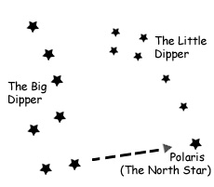

Part C: Movement of the Stars

Northern Circumpolar Constellations
Show students the northern circumpolar constellations. Note that depending on where you live, some constellations are visible all year round and some constellations are seasonal. If you live in the Northern Hemisphere, the constellations that circle around the North Star are visible all year. These are called circumpolar constellation because they travel in circles around the North Star. Since the circumpolar constellations are easily recognized and visible all year, they are a good place to start learning about the night sky. The main circumpolar constellations are Ursa Major, the Great Bear; Ursa Minor, the Little Bear; Draco, the Dragon; Cepheus, the King; and Cassiopeia, the Queen. Students should write the names of the constellations on their diagrams.
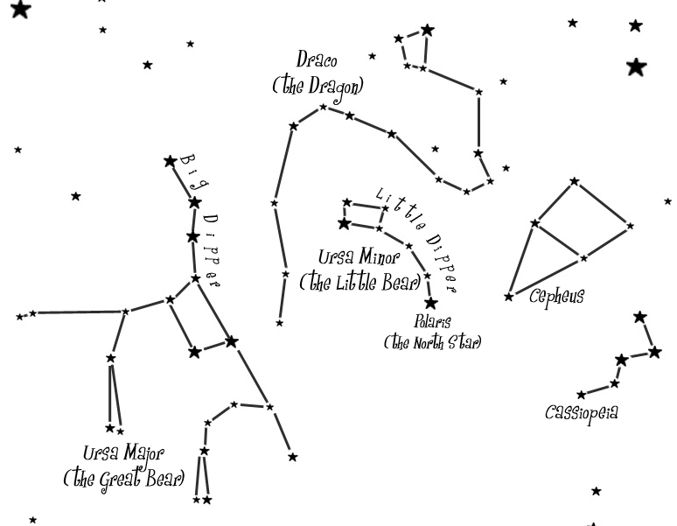

2. Without looking, can you draw the five circumpolar constellations? Note: the diagram has been rotated in order to demonstrate visual understanding.
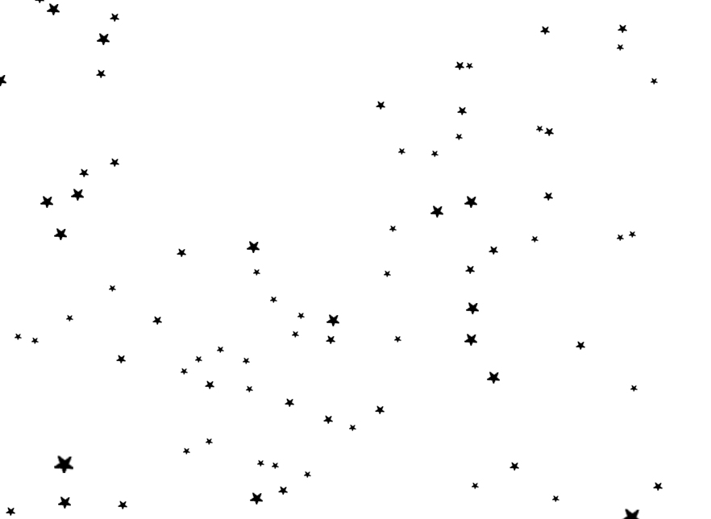

Part D: Latitude and the North Star
Students will use a map to find the latitude of various locations on earth. Also they will use a protractor to measure the angle of the North Star on various locations. These two activities will demonstrate that the angle of the North Star relative to the object’s position will equal the latitude on the map.

What is the latitude on the map of the following locations?
The North Pole | (90 N) | The Tropic of Cancer | (23.5 N)
The Equator | (0) | The Arctic Circle | (66.5 N)
London, England | (51. 32 N) | Washington DC, USA | (38.52N)
Helsinki, Finland | (60.10 N) | Ottawa, Canada | (45.22 N)

Look at the diagrams below. Using a protractor, measure the angle of the North Star relative to the horizon and write down the latitude of the ship. Note: I have left one space blank for the students to create their own drawing and challenge their peers.

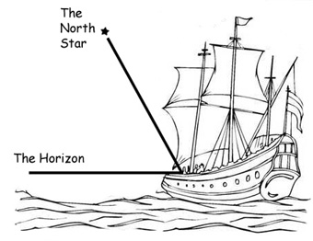 |  | 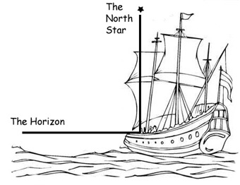
(1) Latitude: ______________________ |  | (2) Latitude: ______________________
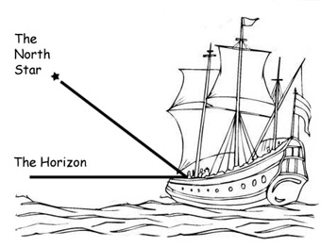 |  | 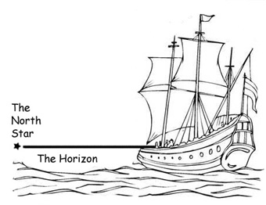
(3) Latitude: ______________________ |  | (4) Latitude: ______________________
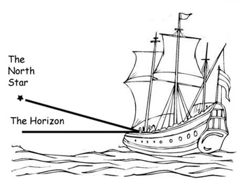
(5) Latitude: ______________________
Summary: Get students to explain.

1. Where would Polaris appear in the sky if you were standing on the North Pole? (straight up.)
2. Where would Polaris appear to someone standing on the equator? (on the horizon.)
3. What does it mean if the North Star sinks below the horizon? (You are in the southern hemisphere)

Part E: 1. Making a Crude Sextant Using Classroom Material

In this class, you will make a crude sextant out of materials that you can easily find in any stationary store. Using your sextant, you can then take a measurement of the North Star and calculate your latitude.  Materials You Will Need:  Protractor  Straw.  Fishing line.  Weight.  Tape.  Paper |  | 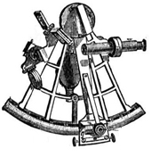  This is a sextant, a tool used by early navigators to measure the angles between stars. With this instrument, they were able to determine their latitude on the map.
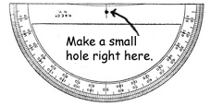 | Step 1: If your protractor doesn’t already have a hole in the center, make a small hole there.
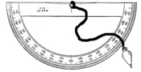  Figure A -The right way to tie the fishing line | Step 2: Tie a small fishing weight to a piece of fishing line and then tie the other end to the protractor. Make sure you tie it the way it is tied in figure A and not the way it is tied in figure B. If you tie it the way it is tied in figure B, your sextant will be inaccurate. It is also a good idea to cut a very tiny groove at the top of the protractor to fit the fishing line into.  Step 3: Turn the protractor upside down and tape a straw along the top. As an option you can add a paper eye guard to eliminate interfering light. Your finished product should look something like the picture below.
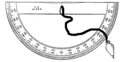
Figure B -The wrong way to tie the fishing line
The Finished Product: A Crude Sextant  To find the angle of elevation of any object, first locate the object in the straw. Next, stop the weight from swinging and press the taught fishing line to the protractor. The angle of elevation is the same as 90 degrees minus the angle you read off of the protractor. In this case the protractor reads 80 degrees so the angle of elevation is 10 degrees. |  |  | 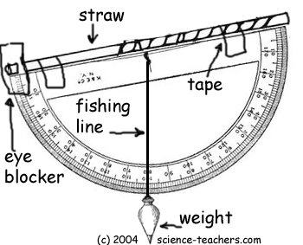

2. Measuring Your Latitude Using a Sextant
Figure 1.  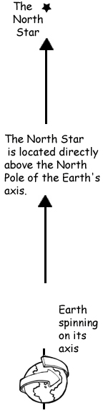  Figure1: The picture to the left shows the North Star is located directly over the Earth’s axis of spin. | Now that you’ve made a sextant, you can take that sextant and measure the angle of objects relative to the horizon. If you examine the diagrams below, you can see that measuring the angle of elevation of the North Star is the same as your latitude on the Earth. So, using your sextant and the stars, you can figure out your latitude on the map. To calculate your latitude use this formula:  Latitude =  90 Degrees – Protractor Angle  Figure 2: As you move from the equator to the North Pole, the angle of elevation of the North Star relative to the horizon changes. |  |  |  | 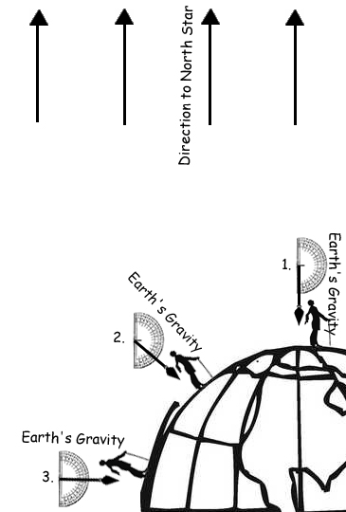  Figure 2
 | Figure 3
 |  | 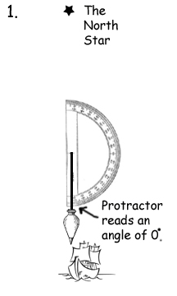 |  | 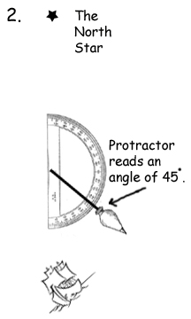 |  | 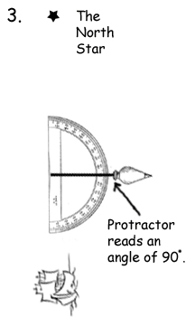
 |  | At the North Pole, your protractor should read 0 degrees. Your latitude is (90-0) degrees. |  | At 45 degrees latitude, your protractor should read 45 degrees. Your latitude is (90-45) degrees. |  | At the equator, your protractor should read 90 degrees. Your latitude is (90-90) degrees.

Summary Questions:
1.True or false, using the North Star, you can estimate exactly where you are. (True. Measure the
altitude of Polaris when departing, To return sail north or south, to bring Polaris to the
altitude of home destination, then turn left or right as appropriate by sailing down the direction of the latitude to keep Polaris at a constant angle.)

2. How could sailors figure out their latitude by looking at the North Star? (Measuring their angle)

3. What tool did sailors use to measure the angle of elevation of stars or the sun? (sextant)

4. Which star is useful in the Northern Hemisphere? (North Star)

Homework: Find the North Star and measure your latitude according to your homemade sextant. (49.53 N)

Justification:
I chose these activities because they are clear visual representations and most learners are visually responsive. All of the activities include hands on manipulation of content knowledge. I like the sextant creation activity because it allows students to be kinesthetically curious while teaching them about past technological tools. Furthermore, connecting what students do in the classroom to their daily life as the sextant homework activity, allows students to explore their learning and consolidate their comprehension.

References:
Science-Teachers.com. (2004). Retrieved February 28, 2008 from
http://www.science-teachers.com/

The National Science Digital Library. TE Activity: The North (Wall) Star. Retrieved February 28, 2008
from http://nsdl.org/resource/2200/20070917003202905T

